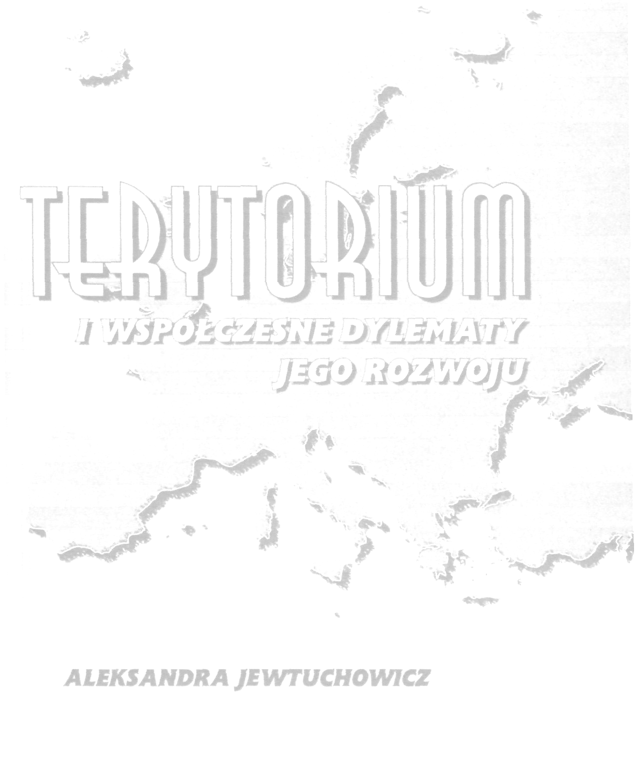
Secretary of the conference:
Ewelina KINA, M.A., Mariusz E. SOKOŁOWICZ, Ph.D.
phone: (+48 42) 63 55 327
fax: (+48 42) 63 55 323
e-mail: regionconf@uni.lodz.pl

University of Łódź

Faculty of Economics and Sociology
Department of Regional Economics and Environment
90-214 Łódź, Rewolucji 1905 Street, no. 39

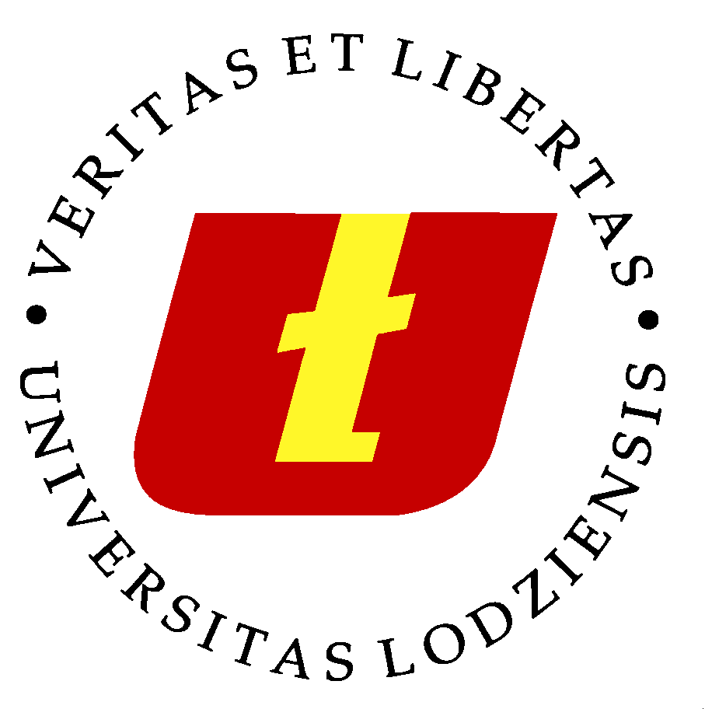
University of Łódź
Faculty of Economics and Sociology
Institute of Spatial Economy
Department of Regional Economics and Environment

International Scientific Conference in Series:
Knowledge, Innovativeness, Entrepreneurship
and Regional Development

TERRITORY AND CONTEMPORARY DILEMMAS OF ITS DEVELOPMENT

JUBILEE CONFERENCE of
Professor Aleksandra Jewtuchowicz

ŁÓDŹ, 24 – 25 OCTOBER 2013

Conference venue: The European Institute in Łódź
262 Piotrkowska Street, 90-361 Łódź

THE AIM OF THE CONFERENCE

Issues concerning the role of space in socio-economic development are becoming to have a much longer history and the scientific fields which attempt to describe and analyze these issues are becoming more complex. Both theory and practice of regional science, regional studies, urban planning, economic geography, environmental protection and urban economics refer to the notion „territory”. It is an expression of the empowerment of local and regional communities and of seeking their own specific ways of development.
The notion “territory” thus becomes more and more significant in the discussion about the future of regional sciences, to which in Poland tries to contribute the school of regional scientists in Łódź centered around the person of Professor Aleksandra Jewtuchowicz.
Referring to the jubilee of 40 years of scientific work of Professor Aleksandra Jewtuchowicz, the cyclical conference of regional scientists in Łódź organized under the theme „Knowledge, Innovativeness, Entrepreneurship and Regional Development” which aim is to share ideas, experience and research results, this time will be devoted primarily to the issue of territory, both in semantic and practical sense of this term. Organizers hope that the conference will be a valuable source of inspiration for further creative work in both theory and practice in the field of regional development, regional policy and spatial economy.
The topic of the conference covers the following basic thematic blocks:
- The essence of territorial dimension of the economic development
- Regional competitiveness and cohesion
- Networks and systems in development of the territory
- Entrepreneurship milieux
- Innovativeness and creativeness of cities and regions
- Urban policy and smart cities

THE CONDITIONS OF PARTICIPATION

Payment for the participation in the conference is 200 euro per person. The conference fee covers the costs of conference materials, meals and special supper as well as the costs of publication.
Publication will have a scientific character. Thus, all papers sent will be a subject of review.
The conference fee does not include the costs of accommodation. At a later date (in June 2013) the organizers will send the participants of the conference the list of hotels in the centre of Łódź and will make appropriate reservations.

DATES OF REGISTRATION:

15 November 2012 deadline for sending the applications

15 December 2012 deadline for payment and sending the papers

Detailed, final program of the conference will be sent to all participants after the dates stated above.

Please transfer the payment to the account of the University of Łódź:

Bank Polska Kasa Opieki S.A. II Oddział w Łodzi
No.: 07 1240 3028 1111 0010 2943 4436

with the postscript: Terytorium

MORE INFORMATION AT: www.region.uni.lodz.pl/konferencjeibadania.html

