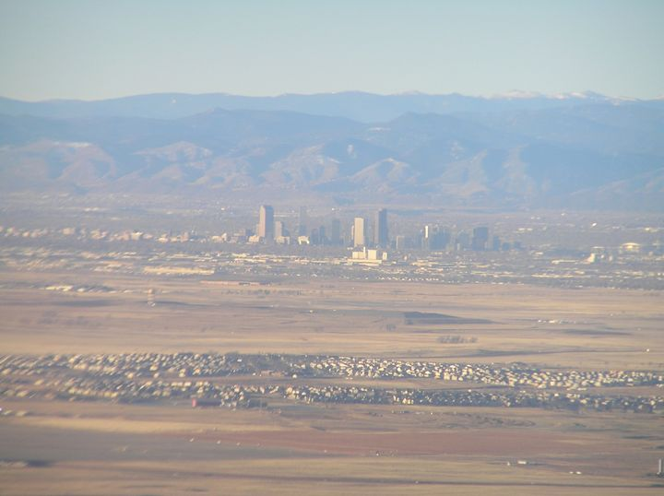

Secretariat of the Conference
Cezary Brzeziński Ph. D;
phone: (+48 42) 63 55 326
(+48 42) 63 55 323
e-mail: regionconf@uni.lodz.pl
University of Łódź
The Faculty of Economics and Sociology
Department of Regional Economics
and Environment
90-214 Łódź, ul. Rewolucji 1905 r. nr 39
University of Łódź
Faculty of Economics and Sociology

Department of Regional Economy
and Environment
www.region.uni.lodz.pl

International Scientific Conference in Series:
Knowledge, Innovativeness, Enterpreneurship and Regional Development.

Strong metropolis - strong region?
ŁÓDŹ, 13-14 MAY 2010
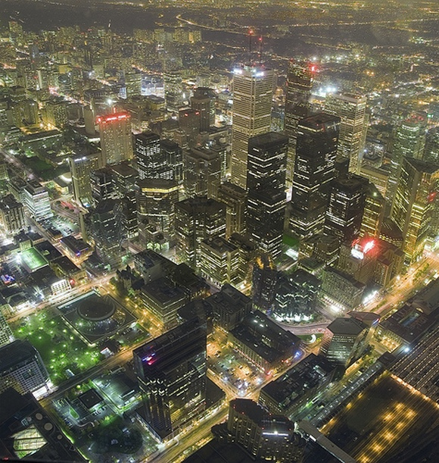
Place of conference and accomodation: Hotel *** Ambasador, Łódź ul. Kosynierów Gdyńskich 8, 93-320 Łódź, phone (+48)(42) 646-49-04, 646-43-22, 646-41-53, www.hotelambasador.pl

THE AIM OF THE CONFERENCE

The processes of metropolisation in regions cause different types of transformations.. Because of that appears a question about the directions of changes in the area of metropolis. In Poland during the period of transformation resulting from system changes and universal processes that globalization brings about, which can be desribed in categories of integration and desintegration. Describing these changes might refer both to the area of metropolis and relationships connecting it with the whole region surrounding it. The conference, refering to the values ling at the basis of new system (such as democratisation, subjectivisation, pluralism, self-government, restoration of territorial identity, economic rationalisation, dynamisation, modernisation, opening for the world, etc.) and resulting from everything that globalisation brings (information technologies, transnational corporations, metropolitan class, universal cultural patterns, cosmopolitism, glocalisation, etc.) will try to identify explain and estimate the directions of restructurisantion of so specific of metropolitan areas are.
The aim of the conference is to create an opportunity of exchanging experiences for everybody interested in the problems concerning challenges which metropolis face in context of globalization and metropolisation processes. The conference is to answer the folloving questions: How to take care of the cohesion of metropolis and prevent its disintegration and how to strengthen the cities` innovation abilities?
The subject of the pronouncements presented during the conference will be concentrated around the following thematic groups:
- Creating innovative abilities of Polish metropolis
- Integration and desintegration processes of metropolis
- The role of metropolis in internalisation of regions
- Governing of metropolitan areas
- The influence of metropolis on regional development

THE CONDITIONS OF PARTICIPATION

The participation fee in the conference is 190 Euro per person. It covers conference and papers, meals and special supper as well as post conference book. The payment does not include the costs of accommodation, which the participant of the conference covers individually. The organizers assure the reservation of accommodation in the Hotel*** Ambasador, Łódź ul. Kosynierów Gdyńskich 8, 93-320 Łódź, www.hotelambasador.pl The price of single room is from approx. 43 Euro (a smaller room) to 51 Euro (standard), a double room 26 Euro per person (with breakfast). Places will be reserved according to the information which you send us in the application form.
The detailed plan of the conference will be sent on receipt of the application forms with the titles of papers.
The publication will be in a form of a scientific monography. That is why the articles sent will undergo a review.
The dates of registrations:

28 February 2010 the deadline for sending the applications
15 March 2010 the deadline for the settlement of payment
30 March 2010 the deadline for sending the paper

Please transfer the payment to the account of the University of Lodz

IBAN: PL 14 1240 3028 1111 0010 0434 7782
BIC/SWIFT: PKOPPLPW
with the postscript : Silna metropolia - silny region ?

More information on: WWW.REGION.UNI.LODZ.PL

